PRODUCT SPECIFICATION

TYPE: LED TV CONTROL BOARD
MODEL: CV352-U42

Approved by Huiguan |  | Approved by Customer
Prepared by: |  | Name:
Checked by: |  | Comments:
Approved by: |  | Approved by:
Date: |  | Date:
Company’s Seal:
We would like you to put your signature to state your approval of the specification, and send it back to us.

ITEM

1. DESCRIPTION 3
2. FEATURES 3
3. CHARACTERISTICS 3
4. FUNCTION CONFIGRATION 5
5. MEDIA FORMAT MODE 6
6. ELECTRICAL CHARACTERISTICS 7
7. PROTECTION CAPABILITY 8
8. INTERNATIONAL STANDARDS 8
9. INTERFACE DEFINITION 10
10. CONFIGURATION 18
11. APPLICATION REQUIREMENT 19
12. EXCURSUS 20
13. TRADEMARK INFORMATION 20

History of Revision

No. | PCBA Rev. | Details of Change | Author | Issue Date
00 | 12 | Initial Release |  | July 16, 2025

1. DESCRIPTION

CV352-U42 is a digital and analog TV control board, It can receive the PAL/SECAM/NTSCanalogue television signals and DVB-C/T/T2/S2/ATSC/ISDB digital television signals, It is suitable for the market in Europe,South america,South america,Asia pacific market.
CV352-U42是数模一体电视控制板，可接收PAL/SECAM/NTSC制式的模拟电视信号和DVB-C/T/T2/S2/ATSC/ISDB制式的数字电视信号。适用于欧洲，南美，北美，亚太市场。
CV352-U42’s power part is an energy-efficient ultrathin DC-line switching power supply unit, with backlight power under 45W, The main promotion backlight voltage is between 30V-110V,And single backlight output. It fits to 32〞 and 42〞LED backlight panel.
CV352-U42采用的高效率开关电源，匹配背光功率45W以下，匹配背光电压为30V-110V，单路背光输出,支持32寸和42寸LED背光屏。

2. FEATURES

HDMI1、HDMI2、HDMI3 supports CEC, HDMI1 support ARC.
HDMI1、HDMI2、HDMI3 支持CEC，HDMI1支持ARC。
The HDMI supports 1.4b, the HDCP supports 1.4.
HDMI 支持1.4b ，HDCP支持1.4。
Supports USB update and playing multimedia and JPEG.
支持USB升级软件，播放多媒体和JPEG。

3. CHARACTERISTICS

PANEL | Type | TFT-LCD/LED
PANEL | Resolution | Max 1920X1080
PANEL | Interface | Single /Double LVDS
PANEL | Voltage | 12V
ATV | Receiving range | 47.25MHz – 867.25MHz
ATV | Input Impedance | 75Ω
ATV | Video System | PAL, NTSC,SECAM
ATV | Sound System | BG, DK, I, L/L’
ATV | Sound System | NICAM/FM/AM/A2
DTV | Receiving range | DVB-T/T2: VHF (42MHz – 230MHz), UHF (474MHz - 862MHz)
DTV | Receiving range | S2(950MHz – 2150MHz)
DTV | Receiving range | ATSC:CH2~CH69
DTV | Receiving range | ISDB-T(177MHz – 803MHz)

 | Input Impedance | 75 Ω
 | Video System | DVB-T/T2/C/S2:MPEG-2 MP@ML, MPEG-2 MP@HL, H.264, H.265:Main/Main-10 profile @L4.1,Support 8-bit/10bit color depth
 | Video System | ATSC:MPEG 2 MP@HL
 | Video System | ISDB：MPEG-2 MP@HL
 | Bandwidth | DVB-T/T2/C/S2:7MHz/8MHz
 | Bandwidth | ATSC/ISDB:6MHz
 | Modulation | DVB-T: COFDM 2/8K, QPSK, 16QAM, 64QAM
 | Modulation | DVB-T2: QPSK, 16QAM, 64QAM, 256QAM
 | Modulation | DVB-C: 16QAM, 32QAM, 64QAM, 128QAM, 256QAM
 | Modulation | DVB-S2: QPSK, 8PSK
 | Modulation | ATSC:8VSB QAM:64QAM, 256QAM
 | Modulation | ISDB-T:DQPSK/QPSK QAM:16QAM, 64QAM
 | Sound System | DVB-T/T2/C/S2:MPEG-1 Layer 1/2, MPEG-2 Layer 2, DD, DD+
 | Sound System | ATSC:MPEG 1/ layer 1/AC-3
 | Sound System | ISDB：MPEG-1 Layer 1/2, MPEG-2 Layer 2, DD, DD+
AV | Color system | PAL/NTSC/ SECAM
AV | Video Level | 1Vp-p@75ohm
HDMI | Format | 480i, 480p, 576i, 576p, 720p, 1080i, 1080p
Processor | CPU | A53 4 Core @max 1GHz
Processor | GPU | Mali450MP2 Dual Core
Processor | O/S | Android 14
Processor | DDR | External *512MB/1GB (Byte) DDR3
Processor | eMMC Flash | *4GB/8GB (Byte)
SUPPORT WLAN | ON BOARD CHIPSET | ATBM6032；AIC8800 WIFI Module
SUPPORT WLAN | Max Data Rate | 150Mbps
SUPPORT WLAN | Operating Frequency | 2.4GHz
SUPPORT WLAN | Communications Standard | IEEE 802.11b/g/n
SUPPORT WLAN | External support list | / |  | /
RJ45 NETWORK | 10/100M auto-identification and DHCP
AUDIO INPUT | CVBS Audio | Audio Level | 0.2----2 Vrms
AUDIO INPUT | Component Audio | Audio Level
AUDIO OUTPUT | Frequency response | 100Hz-15KHz @±3dB（1KHz -12dB reference signal）
AUDIO OUTPUT | Max Output Power | 2*8W @ 8ohm THD+N<10%@1KHz  （Audio Input:0.5Vrms）
Keyboard | POWER
Standby | ≤ 0.5W
The optional items are marked with―*Π.

4. FUNCTION CONFIGRATION

配置一 (25W ，32 寸) / OPTION 1（25W ，32”）
功能: 1GB DDR (2 颗 512MB)，8GB EMMC, 1T1RWIFI(ON BOARD)，内置 PCB WiFi 天线，不带 DB,带 ARC，带 CEC, 12V 屏供电，带 LVDS 输出，RF 螺纹头，RF 直头，不带天线馈电，内置 KEY(出板 2.5mm)，内置 IR/LED
电源: AC 输入 90V 到 264V ，背光电压范围在 30V~85V 之间，背光插座 2PIN2.0+3PIN2.0 立式并联不带卡扣, 不带 EMI
FUNCTIONS: 1GB DDR,8GB EMMC, 1T1R WIFI(ON BOARD) ，with PCB WiFi ANT ，WITHOUT DD+,with ARC ，with CEC, 12V PANEL POWER ，with LVDS OUTPUT， RF F connector ，RF IEC connector ，WITHOUT ANT POWER， INTERNAL KEY/IR/LED
POWER ： AC INPUT 90V-264V, BACKLIGHT VOLTAGE 30V-85V, BACKLIGHT CONNECTOR 2PIN 2.0+3PIN2.0 VERTICAL PARALLEL ，WITHOUT EMI
SIDE VIEW
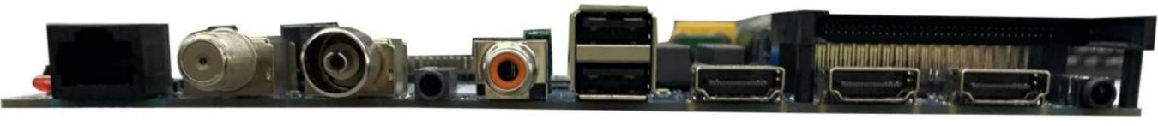
RJ45, TV1(DVB-S2),TV2(DVB-C/T/T2/ATSC/ISDB),MINI AV,COAX, USB(双层), HDMI1(ARC), HDMI2（UART）, HDMI3, EARPHONE, CI.
配置二 (45W ，42 寸) / OPTION 2（45W ，42”）
功能: 1GB DDR (2 颗 512MB)，8GB EMMC, 1T1RWIFI(ON BOARD)，内置 PCB WiFi 天线，不带 DB,带 ARC，带 CEC, 12V 屏供电，带 LVDS 输出，RF 螺纹头，RF 直头，不带天线馈电，内置 KEY(出板 2.5mm)，内置 IR/LED
电源: AC 输入 90V 到 264V ， 背光电压范围在 35V-110V 之间，背光插座 2PIN2.0+3PIN2.0 立式并联不带卡扣, 不带 EMI
FUNCTIONS: 1GB DDR,8GB EMMC, 1T1R WIFI(ON BOARD)，with PCB WiFi ANT，WITHOUT DD+,with ARC，with CEC, 12V PANEL POWER，with LVDS OUTPUT， RF F connector，RF IEC connector，WITHOUT ANT POWER， INTERNAL KEY/IR/LED
POWER：AC INPUT 90V-264V, BACKLIGHT VOLTAGE 35V-110V, BACKLIGHT CONNECTOR 2PIN 2.0+3PIN2.0 VERTICAL PARALLEL，WITHOUT EMI
SIDE VIEW
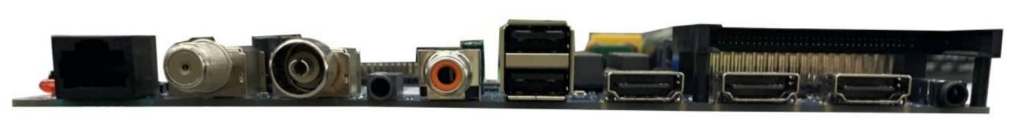
RJ45, TV1(DVB-S2),TV2(DVB-C/T/T2/ATSC/ISDB),MINI AV,COAX, USB(双层), HDMI1(ARC), HDMI2（UART）, HDMI3, EARPHONE, CI.

*REQUIREMENT OF MINI AV WIRE HARNESS
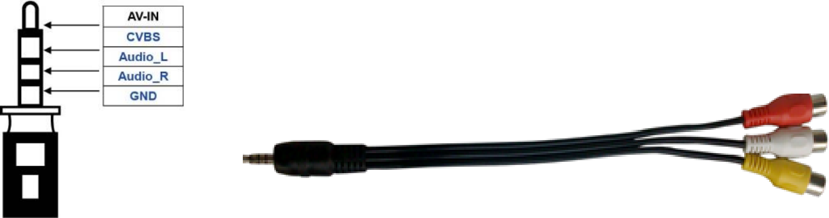

5. MEDIA FORMAT MODE

Media | Codec  format | Max code rate | Specification | profile | File Extension
MOVIE | AVS | 20 Mbps | 1920x1088@60 FPS | baseline@level6.0 | TS
MOVIE | AVS+ | 100 Mbps | 1920x1088@60 FPS | broadcasting  @level6.0.3.08.60 | TS
MOVIE | H264 | 50 Mbps | 1920x1080@60 FPS | BP，MP，HP  @level4.2 | AVI，TS，MPEG，MP4，MOV，  M2TS，MKV，FLV，MTS，  M4V，ASF，F4V，3GP，3G2，  TRP
MOVIE | H265 | 50 Mbps | 1920x1080@60 FPS  10bit | Main/Main-10@L4 .1，high tier | TS，MP4，MOV，MKV
MOVIE | MPEG-1 | 80 Mbps | 1920x1088@30 FPS | MP@LL，ML，HL | AVI，MPEG，DAT， M1V，  M2V
MOVIE | MPEG-2 | 80 Mbps | 1920x1088@30 FPS | MP@LL，ML，HL | AVI，TS，MPEG，M2TS，M2T， VOB，M2V， TP， TRP，M2P
MOVIE | MPEG-4 | 50 Mbps | 1920x1088@30 FPS | SP@L0-3，  ASP@L0-5 | AVI，TS，MP4，MOV， ASF，  3GP，3G2
MOVIE | VC1 | 45 Mbps | 1920x1088@30 FPS | AP@L0～3，  SP@LL，ML，  MP@LL，ML，HL | AVI，TS，M2TS，MKV，ASF
MOVIE | VP6 | 40 Mbps | 1920x1088@30 FPS | - | AVI，FLV
MOVIE | VP8 | 40 Mbps | 1920x1088@30 FPS | - | WEBM
MOVIE | VP9 | 30 Mbps | 1920x1080@60 FPS  10bit | Profile 2（only  8bit/10bits） | WEBM
MOVIE | MJPEG | 150 Mbps | 1920x1088@30 FPS | - | AVI，MOV
SOUND | AAC | 24 kbps ~ 576  kbps | 8 kHz ~ 96 kHz | - | MKA，M4A，AVI，MP4，MOV，  TS
SOUND | AC3 | 32 kbps ~ 640  kbps | 32 kHz，44.1 kHz， 48 kHz | - | MKA，AVI，MP4，TS
SOUND | ADPCM | 384 kbps | 8 kHz ~ 44.1 kHz | - | WAV
SOUND | APE | max 1411  kbps | max 48 kHz | - | APE
SOUND | DTS | max 6Mbps | max 48 kHz | - | MKA，AVI，MP4
SOUND | DTS HD | max  24.567Mbps | max 192 kHz | - | MKA，MP4
SOUND | EAC3 | 32 ~ 6Mbps | 32 kHz，44.1 kHz， 48 kHz | - | TS，MP4
SOUND | FLAC | max 1411  kbps | max 192 kHz | - | MKA，OGG，MOV
SOUND | MID | max 320 kbps | max 48 kHz | - | MID
SOUND | MPEG | 32 kbps ~ 320 | 8 kHz ~ 48 kHz | - | MP3，MKA，AVI，MP4，MPG，

 |  | kbps |  |  | OGG，MOV
 | PCM | max 320 kbps | 8 kHz ~ 192 kHz | - | WAV，MKA，AVI，OGG，MOV
 | TrueHD | max 18Mbps | 2 kHz，44.1 kHz，48 kHz，96 kHz | - | TS
 | Vorbis | max 256 kbps | 8 kHz ~ 48 kHz | - | OGG，MKA，MOV
PICTURE | png | - | 8K*8K | - | -
 | jpeg | - | baseline 8K*8K, progressive 4K*4K | - | -
 | bmp | - | 8K*8K | - | -
 | gif | - | 8K*8K | - | -
Note:
The product includes the following optional patent technology: DD, DD+, DTS, WMA, WMV, RM, RMVB etc.
Related patent license should be provided if you need to use these patents. The above patent using authorization is subject to our actual confirmation.
(本产品包括如下可选的专利技术：DD, DD+, DTS,WMA,WMV,RM,RMVB 等，如您需要开通这些功能，请提前提供相关专利许可给到我司。以上专利使用授权以我司实际确认为准。)

6. ELECTRICAL CHARACTERISTICS

6.1 Input Electrical Specifications

Input | Minimum | Nominal | Maximum | Unit
Voltage | 90 | 240 | 264 | Vac
Current | —— | —— | 2.0 | A
Frequency | 47 | 50/60 | 63 | Hz
Efficiency |  | ≥80%min(Full load with input AC voltage of 110Vac @ 60Hz and 240Vac @ 50Hz)
Standby Power Consumption |  | ≦0.5W At 240Vac input and no load condition
Inrush current |  | Cannot be damaged components
Leakage Current |  | Less Than 0.35mA, 240Vac input
Input Fuse |  | T3.15AL/250VAC

6.2 LED Driver Power Output Connector&output characteristics PJ22/PJ24: 2/2PIN-2.0
NO. | SYMBOL | DESCRIPTION
1 | LED+ | LED+ Power Supply
2 | LED- | LED- Power Supply

PJ23/PJ25: 2/3PIN-2.0

NO. | SYMBOL | DESCRIPTION
1 | LED+ | LED+ Power Supply
2 | LED- | LED- Power Supply
3 | LED- | LED- Power Supply

PCON1: AC INPUT CONNECTOR

NO. | SYMBOL | DESCRIPTION
1 | L | LIVE（火线）
2 | N | NEUTRAL（零线）

7. PROTECTION CAPABILITY

LED Short Protection: （LED 短路保护）
Auto restart (自动恢复)
LED Open Protection: （LED 开路保护）
Shut down or auto restart（关断或自动恢复）
Fuse protection（保险丝过流保护）
The Fuse inside the power supply shall open when the AC input current is over the rated current of fuse. This Fuse protection will cause switching power supply to fail.
（当 AC 输入电流超过电源内置保险丝的额定电流时，保险丝必须熔断，呈开路状态，保险丝保护启动后电源将不能启动。）

8. INTERNATIONAL STANDARDS

EMI standards（EMI 标准）
The power supply shall compliance with the following radio disturbance Criterion.
该电源应符合下列无线电干扰标准。
Sound and television broadcast receivers and associated equipment

EN55013 | Sound and television broadcast receivers and associated equipment radio disturbance characteristics limits and methods of measurement
GB13837 | 声音和电视广播接收机及有关设备无线电干扰特性限值和测试方法
FCC CFR 47 Part 15 subpart B 美国联邦通信法规第47 卷 15 章内无意式的辐射器材的相关规定

EMS standards（EMS 标准）

Electrostatic Discharge Immunity Test: IEC-1000-4-2 8KV, Criteria B
（防静电测试标准：IEC-1000-4-2 touch discharge ±4KV,air discharge ±8KV, Criteria B）
EFT/Burst Immunity Test: IEC-1000-4-4 1KV, Criteria B
（快速脉冲群测试标准：IEC-1000-4-4 1KV, Criteria B）

Safety Compliance（安规依据）
Design to meet : IEC60950 / 2005; IEC60065
（设计依据：IEC60950 / 2005; IEC60065）

Isolation（绝缘性能）
Insulation resistance（绝缘阻抗）

Input To Output | DC500V 50MΩmin (at room temperature)
Input To PG | DC500V 50MΩmin (at room temperature)
Insulation voltage（绝缘耐压）

Input To Output | 3000Vac 50Hz 1minute ≤10mA
Input To PG | 1500Vac 50Hz 1minute ≤10mA

9. INTERFACE DEFINITION

The picture is for a reference only,the actual item is the standard.
The optional connectors and terminals are marked with)*Π.

JAGE1: | 12V AGING TEST CONNECTOR
JL1: | LVDS CONNECTOR
JA1: | SPEAKE CONNECTOR
*JK2: | KEY&IR CONNECTOR
PJ22/*PJ23/  *PJ24/PJ25 | LED BLACK LIGHT  CONNECTOR
*J2/J6/JL3 | TCONLESS CONNECTOR

All jack recognize the square pad as first pin.

JAGE1 POWER SUPPLY CONNECTOR (2PIN/2.0)

NO. | SYMBOL | DESCRIPTION
1 | +12V | +12V Power Supply
2 | GND | Ground

JL1 LVDS INTERFACE(2×15PIN/2.0)（LVDS 插针接口）

NO. | SYMBOL | DESCRIPTION
1 | VCC | Power Supply for Panel
2 | VCC | Power Supply for Panel
3 | VCC | Power Supply for Panel
4 | GND | Ground
5 | GND | Ground
6 | NC | NC
7 | RXO0- | LVDS ODD 0- Signal
8 | RXO0+ | LVDS ODD 0+ Signal
9 | RXO1- | LVDS ODD 1- Signal
10 | RXO1+ | LVDS ODD 1+ Signal
11 | RXO2- | LVDS ODD 2- Signal
12 | RXO2+ | LVDS ODD 2+ Signal
13 | GND | Ground
14 | GND | Ground
15 | RXOC- | LVDS ODD Clock- Signal
16 | RXOC+ | LVDS ODD Clock+ Signal
17 | RXO3- | LVDS ODD 3- Signal
18 | RXO3+ | LVDS ODD 3+ Signal
19 | RXE0- | LVDS EVEN 0- Signal
20 | RXE0+ | LVDS EVEN 0+ Signal
21 | RXE1- | LVDS EVEN 1- Signal
22 | RXE1+ | LVDS EVEN 1+ Signal
23 | RXE2- | LVDS EVEN 2- Signal
24 | RXE2+ | LVDS EVEN 2+ Signal
25 | GND | Ground

26 | GND
27 | RXEC- | LVDS EVEN Clock- Signal
28 | RXEC+ | LVDS EVEN Clock+ Signal
29 | RXE3- | LVDS EVEN 3- Signal
30 | RXE3+ | LVDS EVEN 3+ Signal

JL3 TCONLESS INTERFACE(51PIN/0.5)（TCONLESS 接口）
NO. SYMBOL DESCRIPTION
1
2
VCC +12V DC Power for panel
3
4
5 NC No Connection 6
7 GND Ground 8
9
10
NC No Connection
11
12
13 NC No Connection
14 NC No Connection
15 GND Ground
16 RXEC+ LVDS EVEN Clock+ Signal
17 RXEC- LVDS EVEN Clock- Signal
18 GND Ground
19 RXE2+ LVDS EVEN 2+ Signal
20 RXE2- LVDS EVEN 2- Signal
21 RXE1+ LVDS EVEN 1+ Signal
22 RXE1- LVDS EVEN 1- Signal
23 RXE0+ LVDS EVEN 0+ Signal
24 RXE0- LVDS EVEN 0- Signal
25 POL2 Polarity control for source driver 2
26 POL Polarity control for source driver

27 | Terminate | Input signal for level shifter to pull low in blank time
28 | LC | Input signal for level shifter(Low frequency clock)
29 | RXO3+ | LVDS ODD 3+ Signal
30 | RXO3- | LVDS ODD 3- Signal
31 | GND | Ground
32 | RXOC+ | LVDS ODD Clock+ Signal
33 | RXOC- | LVDS ODD Clock- Signal
34 | GND | Ground
35 | RXO2+ | LVDS ODD 2+ Signal
36 | RXO2- | LVDS ODD 2- Signal
37 | RXO1+ | LVDS ODD 1+ Signal
38 | RXO1- | LVDS ODD 1- Signal
39 | RXO0+ | LVDS ODD 0+ Signal
40 | RXO0- | LVDS ODD 0- Signal
41 | GND | Ground
42 | STV0 | Input signal for level shifter(start pulse for GOA)
43 | NC | No Connection
44 | NC | No Connection
45 | NC | No Connection
46 | CPV2 | Input signal for level shifter(condensed clock2)
47 | CPV1 | Input signal for level shifter(condensed clock1)
48 | GND | Ground
49 | NC | No Connection
50 | NC | No Connection
51 | NC | No Connection

J2 TCONLESS INTERFACE(60PIN/0.5)（BOE_TCONLESS 接口）


NO. | SYMBOL | DESCRIPTION
1 | GND | Ground
2 | RXEC+ | LVDS EVEN 5- Signal
3 | RXEC- | LVDS EVEN 5+ Signal
4 | RXE2+ | LVDS EVEN 4- Signal
5 | RXE2- | LVDS EVEN 4+ Signal
6 | RXE1+ | LVDS EVEN 3- Signal
7 | RXE1- | LVDS EVEN 3+ Signal
8 | GND | Ground
9 | RXOC+ | LVDS ODD Clock+ Signal
10 | RXOC- | LVDS ODD Clock- Signal
11 | GND | Ground

12 | RXE2+ | LVDS EVEN 2+ Signal
13 | RXE2- | LVDS EVEN 2- Signal
14 | RXE1+ | LVDS EVEN 1+ Signal
15 | RXE1- | LVDS EVEN 1- Signal
16 | RXE0+ | LVDS EVEN 0+ Signal
17 | RXE0- | LVDS EVEN 0- Signal
18 | GND | Ground
19 | GND | Ground
20 | NC | NC
21 | NC | NC
22 | NC | NC
23 | NC | NC
24 | NC | NC
25 | NC | NC
26 | NC | NC
27 | NC | NC
28 | NC | NC
29 | NC | NC
30 | NC | NC
31 | NC | NC
32 | NC | NC
33 | NC | NC
34 | GND | Ground
35 | AVDD | Power supply for analog circuit
36 | AVDD | Power supply for analog circuit
37 | AVDD | Power supply for analog circuit
38 | VMID | Power supply for analog circuit VMID=1/2AVDD
39 | VMID | Power supply for analog circuit VMID=1/2AVDD
40 | PAIRMODE | Selects mini-LVDS input mode
41 | POL | Source driver polarity inversion signal
42 | TP | Source driver latch signal
43 | NC | NC
44 | VCOM | common electrode for LCD
45 | VCOM | common electrode for LCD
46 | GREF | Power supply for GAMMA reference
47 | VON | Positive power supply for Level shift
48 | VON | Positive power supply for Level shift
49 | GND | Ground
50 | VOFF | Negative power supply for Level shift
51 | VOFF | Negative power supply for Level shift
52 | DVDD | Power supply for digital circuit.
53 | DVDD | Power supply for digital circuit.
54 | GND | Ground

55 | NC | NC
56 | NC | NC
57 | STV1 | STV1 input for Level shift
58 | STV0 | STV0 input for Level shift
59 | CPV2 | Clock2 input for Level shift
60 | CPV1 | Clock1 input for Level shift

J6 TCONLESS INTERFACE(60PIN/0.5)（HKC/AUO_TCONLESS 接口）

NO. | SYMBOL | DESCRIPTION
1 | NC | NC
2 | GND | Ground
3 | RXEC+ | HKC_LVDS EVEN 5- Signal/AUO_NC
4 | RXEC- | HKC_LVDS EVEN 5+ Signal/AUO_NC
5 | RXE2+ | HKC_LVDS EVEN 4- Signal/AUO_NC
6 | RXE2- | HKC_LVDS EVEN 4+ Signal/AUO_NC
7 | RXE1+ | HKC_LVDS EVEN 3- Signal/AUO_NC
8 | RXE1- | HKC_LVDS EVEN 3+ Signal/AUO_NC
9 | GND | Ground
10 | RXOC+ | LVDS ODD Clock+ Signal
11 | RXOC- | LVDS ODD Clock- Signal
12 | GND | Ground
13 | RXE2+ | LVDS EVEN 2+ Signal
14 | RXE2- | LVDS EVEN 2- Signal
15 | RXE1+ | LVDS EVEN 1+ Signal
16 | RXE1- | LVDS EVEN 1- Signal
17 | RXE0+ | LVDS EVEN 0+ Signal
18 | RXE0- | LVDS EVEN 0- Signal
19 | GND | Ground
20 | NC | NC
21 | WP | IIC write protect
22 | SDA | IIC data signal
23 | SCL | IIC clock signal
24 | GND | Ground
25 | NC | NC
26 | NC | NC
27 | VDD33 | Power supply for digital circuit
28 | VDD33 | Power supply for digital circuit
29 | NC | NC
30 | GND | Ground

31 | HAVDD | HKC_NC/AUO_Power supply for source IC
32 | HAVDD | HKC_NC/AUO_Power supply for source IC
33 | VAA | Power supply for analog circuit
34 | VAA | Power supply for analog circuit
35 | VAA | Power supply for analog circuit
36 | NC | NC
37 | NC | NC
38 | GND | Ground
39 | GND | Ground
40 | NC | NC
41 | POL | Source driver polarity inversion signal
42 | TP | Source driver latch signal
43 | GND | Ground
44 | VSS | Power voltage for GOA circuit
45 | VSSQ | HKC_NC/Power voltage for GOA circuit
46 | LC2 | Gout pull down circuit controlling signal
47 | LC1 | Gout pull down circuit controlling signal
48 | NC | NC
49 | ST | GOA scan circuit start pulse
50 | GND | Ground
51 | VGHD | HKC_NC/AUO_ON
52 | CK8 | Clock input of GOA scan circuit
53 | CK7 | Clock input of GOA scan circuit
54 | CK6 | Clock input of GOA scan circuit
55 | CK5 | Clock input of GOA scan circuit
56 | CK4 | Clock input of GOA scan circuit
57 | CK3 | Clock input of GOA scan circuit
58 | CK2 | Clock input of GOA scan circuit
59 | CK1 | Clock input of GOA scan circuit
60 | NC | NC

JA1 SPEAKER CONNECTOR(4PIN/2.54/BTL)（喇叭输出接口）

NO. | SYMBOL | DESCRIPTION
1 | ROUT+ | Audio R+ Channel Output
2 | ROUT- | Audio R- Channel Output
3 | LOUT- | Audio L- Channel Output
4 | LOUT+ | Audio L+ Channel Output

*JK2 KEY&IR BOARD CONNECTOR(14PIN/2.0)（按键、遥控控制接口）

NO. | SYMBOL | DESCRIPTION
1 | GND | Ground
2 | K7 | EXIT
3 | K6 | POWER
4 | K5 | RIGHT/V+
5 | K4 | LEFT/V-
6 | K3 | INPUT
7 | K2 | UP/CH+
8 | K1 | DOWN/CH-
9 | K0 | MENU
10 | GND | Ground
11 | IR | IR Receiver
12 | LED G | Green Indicator
13 | LED R | Red Indicator
14 | +5V | +5V DC Power Supply

10. CONFIGURATION
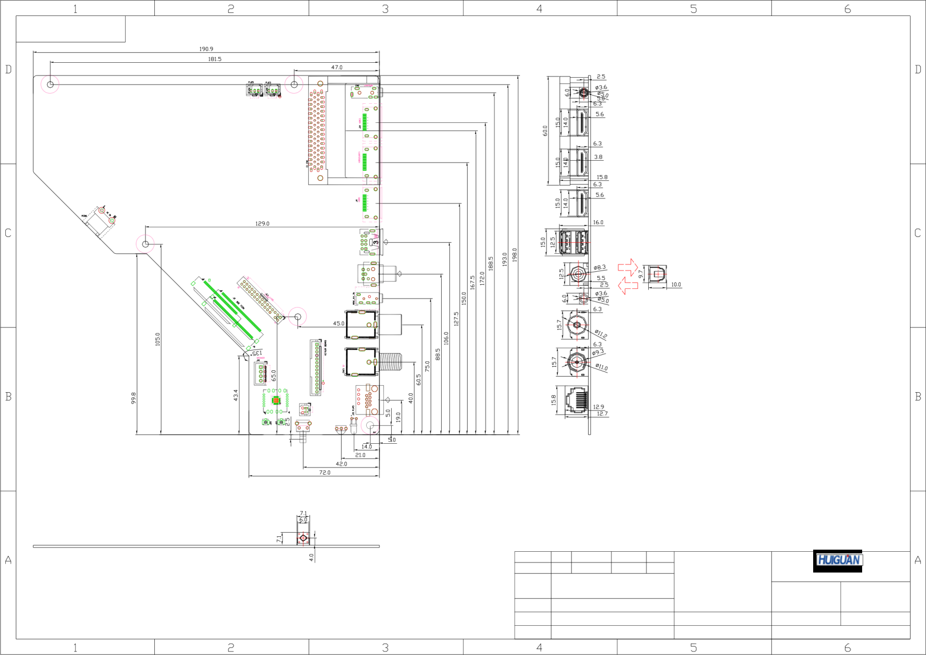
CI
HDMI2 HDMI3 EARPHONE
HDMI1
USB
USB
COAX
OPTICAL
MINI
AV
RJ45 TV1(S2) TV2
KEY
Notes:
The PCB board is thick :1.2mm
Component the tallest altitude:16.5mm Install diameter inside the bore 3.5mm
The length, width, height and aperture of tolerance: 0.2mm
25.06
板型名
(CV352-U42)
更改标记
数量
更改单号
签 名
日期
设 计
版本:1.0
纸张:A4
审 核
物料编号
第 1 页
共 1 页
批 准
未特殊说明尺寸单位为毫米

11. APPLICATION REQUIREMENT

l Relative humidity ≤80%.

l Store temperature -10~+60 ℃ .

l Use temperature 0~+40 ℃ .

l Don't force, distort or disassemble the product.

l Don’t power on before all interface has been correctly connected.

l Avoid to using long conductive wire which may affect performance and image quality.

l Authentication of assembly machine mostly depends on the matching, please use complete machine to test and confirm.
l In order to avoid the I2C-bus address conflict, please contact our hardware engineer before using the I2C interface to communicate with peripheral device.

 The product has limited ESD protection. It should be placed in conductive foam to prevent electrostatic

12. EXCURSUS

Keyboard and remote definition
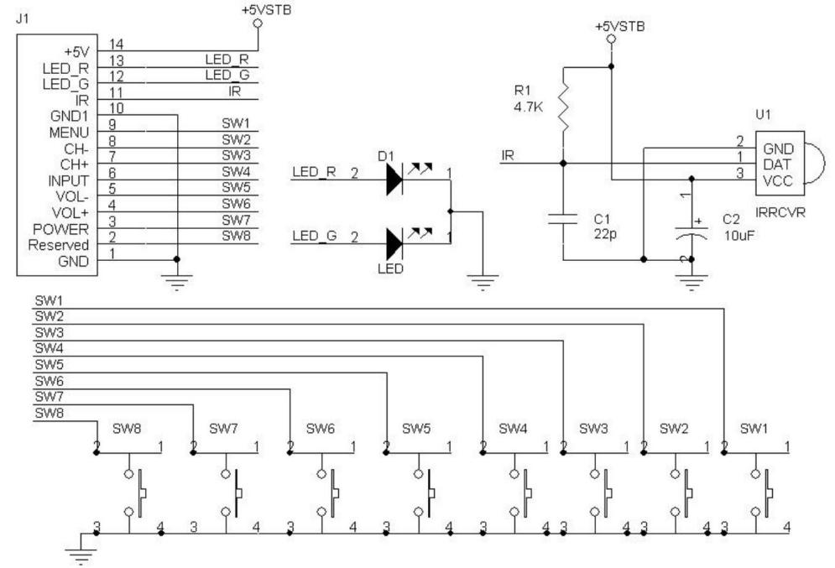

13. TRADEMARK INFORMATION


HDMI, HDMI High-Definition Multimedia Interface, HDMI trade dress and the
HDMI Logos are trademarks or registered trademarks of HDMI Licensing Administrator, Inc. in the United States and other countries.

